Selecting Shingle Grade & Establishing Exposure
The first step is to select a grade of shingles. Once grade is established, (see table below) exposure will dictate batten spacing (and shingle exposure).

Maximum Exposure
Guidelines (mm) Roof
 | Roof Pitch
Shingle Grade | 1:4 to1:3 | > 1:3
Shingle Grade | 14 to 18⁰ | > 18⁰
Shingle Grade | 25 to 33% | > 33%
A | 100 | 125
B | 90 | 100

Conditioning
Shingles should spend at least 2 or 3 days acclimatizing to their future home from a humidity point of view. (Ie. Move shingles from dry heated warehouse to outside location to condition 2-3 days before installing.)

Battens
Battens should be of sufficient size to support shingles and roof loads as well as to readily accept and hold nails. (In Canada battens made from pine or spruce wood measure 2,75 x 7,5cm) Horizontal battens should be installed over vertical battens that are positioned to offer sufficient support for roof shingles and loads (traffic and snow where applicable) as well as to permit free flow of air from eave to ridge.

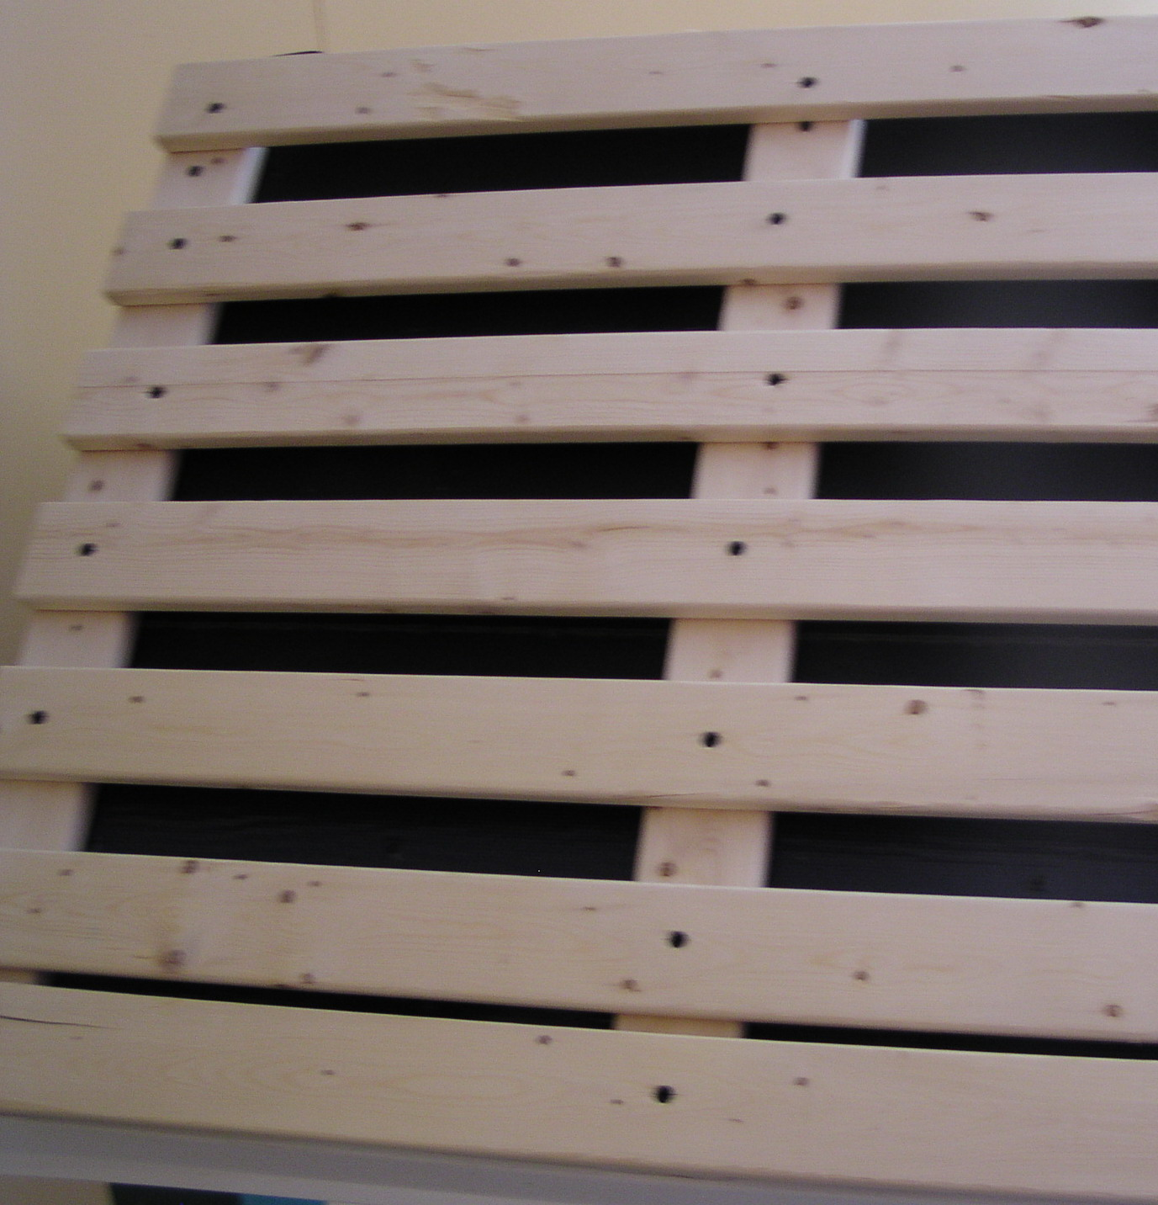
Second batten course should be spaced at a distance that allows for nailing in batten centre at the exposure PLUS about 4cm from eave drip edge. Subsequent courses are spaced at a distance equal to the exposure (so for 100mm exposure battens will be nailed on 100mm at center or at 100, 200, 300, 400 mm…) Adjust batten spacing of top 1-2 meters to avoid partial course at the ridge. (Example: For balance of 950 cm , space last top 10 rows of battens at 95mm intervals instead of 100mm.)

Shingle Spacing
-Shingle should be spaced (side-to-side) at about 2 mm for wet shingles and up to 3-4 mm for dry shingles applied in a humid or damp climate.
-Offset joints on adjacent courses (sidelap) by at least 38mm

The First Course
With butt (the thicker end of the shingle) facing down towards eave - overhang deck drip edge at the eave by 4cm and extend 2cm at the rake (side edge). This course should be preceded by either one or two under courses.

If using a single under course, this course should overhang by 2cm. The first full course is installed overhanging the under course by 2cm.

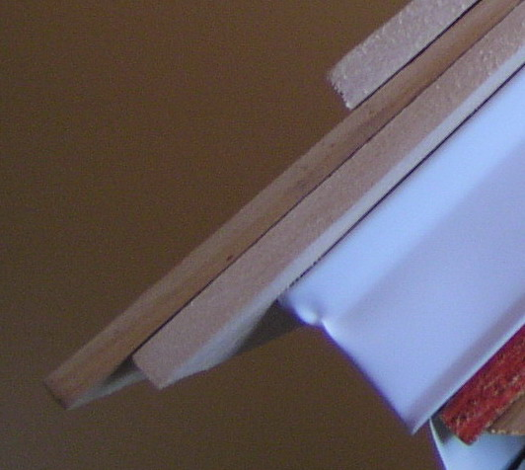

NOTE: This is an excellent spot to use less-than perfect shingles. Lower grade shingles are also permitted for under courses. An experienced roofer will sort through the first two or three bundles to identify less desirable shingles.

(Cont’d)
The roofer will also set aside such shingles as he progresses up the roof for use near the top of the roof where there is less running water.
If using two under courses, each course up to the first full course should overhang the previous course by about 13mm. (This overhang allows maximum eave protection but avoids a double or triple butt that would be slower to dry)

Nailing Guidelines
Corrosion Resistant
Both nails and staples are acceptable for fixing cedar shingles. Hot dipped galvanized are more resistant than those that are electro-galvanized. In maritime climates – stainless steel or copper nails may be required.
NOTE: ACQ treated shingles are very corrosive to common steel. It is necessary to use double-galvanized or stainless steel fasteners.

Thickness and Length
Select nails with a 2mm thick shank or 16 guage staples with a 7/16” (13mm) crown. Either should penetrate through or at least 2cm into the battens. (length of 1-1/2” (about 38mm) suffice for as little as 95 mm exposure) and 1-1/4” (about 32mm ) for 125mm exposure)

Install TWO nails per shingle
A 2cm from each edge
AND
B In centre of batten about 4cm above exposure line (Ie. 10cm+4cm for 100mm exposure)
C Nails or staples should be driven until heads are flush with shingles but not so hard as to crush the surface of the wood.

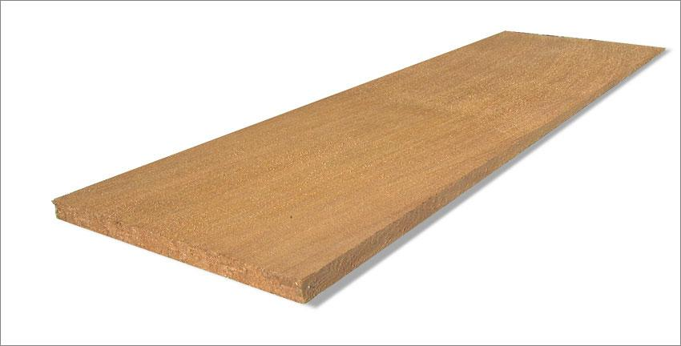
A=2cm
B=14cm

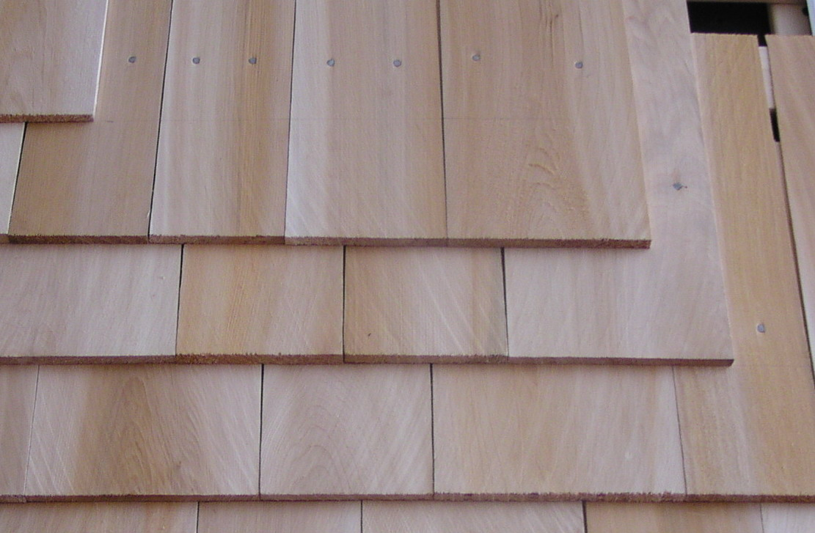

Fixing Quantity Calculation
Average shingle width (mm) | shingles exposure (cm)
Average shingle width (mm) | 10 | 13 | 16 | 20
125 | 176 | 139 | 116 | 96
150 | 147 | 116 | 97 | 80
175 | 126 | 99 | 83 | 69

Note: Joints must be offset by at least two courses
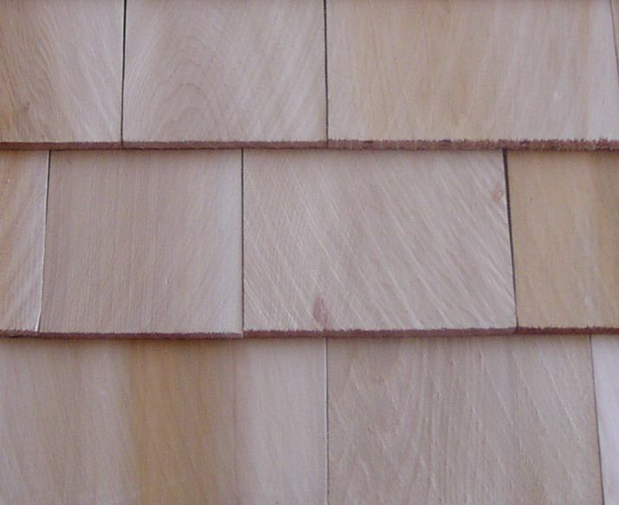
Avoid alignment with only one course separating
(Do not align shingles as shown above with only one course in between)
Valleys
Valleys should be treated according to local practices (using for example metal flashing or membrane) but in any case protect at least 25 cm either side of valley centre. Take care to verify compatibility between all metals used on roof flashing and ACQ treatment where applicable etc..
Hips and Ridges
-Select or cut shingles to the same width as application exposure (ie 10 or 13 cm)
-Install metal flashing or self sealing membrane to reach down at least 20cm either side of hip or ridge
-Install shingles from lower end of hip up using same exposure as roof (doubling first course). Shingle edges should be a) bevel cut and bevel should b) alternate (left and right) on each course.
-Install ridges using same procedure starting at both ends to finish in the middle of each ridge.

Appearance
Eastern white shingles will age to a silver grey over time. Shingles may also be stained or painted but must first be allowed to dry. Contact dealer for details.

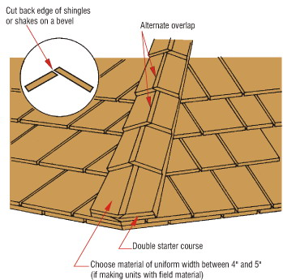

Wall Installation
Follow basic instructions for roofing as well as the following;

Battens
Space battens to allow nailing 4cm above exposure line through batten centre (generally 125-150cm intervals). Allow space for air to enter at bottom and exit at top of wall (about 1cm).
Choosing Wall Shingles
Grade A and B shingles may be chosen for any sidewall application. In applying Grade B shingles, any imperfections (such as knots) are to be treated as the edge of a shingle (keep overlaying shingle joints at least 38mm away).

Grade C shingles (with exposed sound knots) may be used on interior applications or on out buildings or in low exposure areas (large roof overhang).

Shingle Grade | Exposure  Range (mm)
A | 90 -150
B | 90 -125
C | 90-125

Corner Details
Corners may be achieved by alternating and overlapping the course from each wall or with boards (sometimes painted or stained to contrast) to cover up corner entirely.

GLOSSARY

Butt - the thicker end of the shingle
Bundle – a unit of packaging that will cover approximately 2,3m² based on 125mm exposure
Exposure – the portion of shingle exposed to weather (uncovered by another shingle)
Course – a horizontal row forming one of a series of rows on a roof or wall.
Rebutted & Rejointed Shingles (R&R) – shingles which have been remilled to be parallel and Butts retrimmed so as to be at right angles with edges.

